AI Assistant Usage in Student Life
Full-stack Business Intelligence solution

Ai assistant usage in student life
Prepared by: Ibrahim Hegazi
Date: 1/7/2026

Table of Contents
Contents
Table of Contents 2
1. Data Overview 3
1.1 Analytical Questions 4
2. Conceptual, Logical & Physical Model 5
2.1 Logical Model 6
2.2 Physical Model 7
3. SSIS Overview 8
4. SSAS Overview 9
5. Power BI Overview 10

1. Data Overview
The project is based on a AI Assistance Usage in Student Life Dataset comprising 10,000 rows. The dataset is used to build a full-stack Business Intelligence solution using Python for EDA, SQL for Schema Creation, SSIS for ETL, SSAS Tabular for analytics, and Power BI for interactive reporting.

Data Source
• Input Format: CSV file
• Columns: SessionID, StudentLevel, Discipline, SessionDate, SessionLengthMin, TotalPrompts, TaskType, AI_AssistanceLevel, FinalOutcome, UsedAgain, StatisfactionRating

Data Dictionary / Catalog
Column Name | Description
SessionID | Unique identifier for each student session
StudentLevel | Student's academic level
Discipline | Academic subject area
SessionDate | Date when the session occurred
SessionLengthMin | Total session duration in minutes
TotalPrompts | Number of AI prompts/questions generated during the session
TaskType | Type of learning task
AI_AssistanceLevel | Level of AI assistance provided
FinalOutcome | Final result of the session/assignment
UsedAgain | Whether the student returned for another session
SatisfactionRating | Student satisfaction rating after session

Data Profiling
- SessionID
Attribute | Details
Classification | IDENTIFIER
Data Type | str
Unique Values | 10000
Missing Values | 0 (0.0%)
Sample Values | SESSION00001, SESSION00002, SESSION00003
String Checks | Empty: 0, Whitespace: 0
Casing | 100% Uppercase
Length | Min: 12, Max: 12, Avg: 12.00
Action | DROP for modeling (use as index only)

- StudentLevel
Attribute | Details
Classification | CATEGORICAL
Data Type | str
Unique Values | 3
Missing Values | 0 (0.0%)
Sample Values | Undergraduate, Undergraduate, Undergraduate
String Checks | Empty: 0, Whitespace: 0
Casing | 100% Title Case
Length | Min: 8, Max: 13, Avg: 11.60
Action | One-hot or frequency encode if the endgoal is AI training

- Discipline
Attribute | Details
Classification | CATEGORICAL
Data Type | str
Unique Values | 7
Missing Values | 0 (0.0%)
Sample Values | Computer Science, Psychology, Business
String Checks | Empty: 0, Whitespace: 0
Casing | 100% Title Case
Length | Min: 4, Max: 16, Avg: 9.01
Action | One-hot or frequency encode if the endgoal is AI training

- SessionDate
Attribute | Details
Classification | TEXT_DATE
Data Type | str
Unique Values | 366
Missing Values | 0 (0.0%)
Sample Values | 2024-11-03, 2024-08-25, 2025-01-12
Date Range | 2024-06-24 to 2025-06-24
Future Dates | 0
Format Issues | 0 (100% valid)
Timeline Gaps | 0 (continuous daily coverage)
Action | Convert to datetime, extract features

- SessionLengthMin
Attribute | Details
Classification | CONTINUOUS
Data Type | float64
Unique Values | 4078
Missing Values | 0 (0.0%)
Sample Values | 31.2, 13.09, 19.22
Min | 0.03
Max | 110.81
Mean | 19.85
Median | 16.65
Std Dev | 13.9
Zero Count | 0
Negative Count | 0
Skewness | 1.35 (Right-skewed)
IQR Outliers | 302 (Upper bound: 52.23)
Action | Scale & check outliers (cap at 52.23)

- TotalPrompts
Attribute | Details
Classification | COUNT_DATA
Data Type | int64
Unique Values | 37
Missing Values | 0 (0.0%)
Sample Values | 11, 6, 5
Min | 1
Max | 39
Mean | 5.61
Median | 4
Std Dev | 4.65
Zero Count | 0
Negative Count | 0
Skewness | 1.77 (Highly Right-skewed)
IQR Outliers | 265 (Upper bound: 17.00)
Action | Poisson/Negative Binomial models

- TaskType
Attribute | Details
Classification | CATEGORICAL
Data Type | str
Unique Values | 6
Missing Values | 0 (0.0%)
Sample Values | Studying, Studying, Coding
String Checks | Empty: 0, Whitespace: 0
Casing | 100% Title Case
Length | Min: 6, Max: 13, Avg: 8.52
Action | One-hot or frequency encode

- AI_AssistanceLevel
Attribute | Details
Classification | ORDINAL
Data Type | int64
Unique Values | 5
Missing Values | 0 (0.0%)
Sample Values | 2, 3, 3
Min | 1
Max | 5
Mean | 3.48
Median | 4
Std Dev | 0.99
Zero Count | 0
Negative Count | 0
Skewness | -0.24 (Slightly Left-skewed)
IQR Outliers | 241 (Lower bound: 1.50)
Action | Preserve order (ordinal encoding)

- FinalOutcome
Attribute | Details
Classification | CATEGORICAL
Data Type | str
Unique Values | 4
Missing Values | 0 (0.0%)
Sample Values | Assignment Completed, Assignment Completed, Assignment Completed
String Checks | Empty: 0, Whitespace: 0
Casing | 100% Title Case
Length | Min: 7, Max: 20, Avg: 14.79
Action | One-hot or frequency encode

- UsedAgain
Attribute | Details
Classification | BINARY
Data Type | bool
Unique Values | 2
Missing Values | 0 (0.0%)
Sample Values | True, True, True
Action | Use as 0/1 directly

- SatisfactionRating
Attribute | Details
Classification | CONTINUOUS
Data Type | float64
Unique Values | 41
Missing Values | 0 (0.0%)
Sample Values | 1.0, 2.0, 3.3
Min | 1
Max | 5
Mean | 3.42
Median | 3.5
Std Dev | 1.14
Zero Count | 0
Negative Count | 0
Skewness | -0.34 (Slightly Left-skewed)
IQR Outliers | 0 (No outliers)
Action | Scale & check outliers

Data Issues Found During EDA
Issue Description | Suggested Way On How i will Solve it
In SessionID the word 'SESSION' should be removed from it | Remove the SESSION word from each row in this dataset
SessionID Data Type is str | Change the data type to int or index optimized data type
SessionDate Data Type is str | Change the data type to date
AI_AssistanceLevel Column Header is not standardized in terms of the formatting like other columns and contains a special charater that is used for readability | Choose a formatting and use it on all of the column headers.
Consistency Check shows us outliers unrealistic speed | Nothing, Sadly we can't confirm if it is unrealistic speed, we would have needed extra columns for that shows us the length of each prompt. This case could happen if a new user is trying the AI tool for the first time and prompting 'Hi'

1.1 Analytical Questions
Q1: Session Length Optimization
"What is the optimal session length (SessionLengthMin) that maximizes satisfaction rating (SatisfactionRating) for students of different levels (StudentLevel), to identify the ideal session duration for each student segment?

Q2: Task Type & AI Effectiveness
"How does the effectiveness of AI_AssistanceLevel vary across different TaskTypes (6 categories) in predicting FinalOutcome, to prioritize AI feature development for the most impactful task types?"

Q3: Subject Difficulty & Performance
"Which Disciplines (7 categories) show the strongest relationship between TotalPrompts and FinalOutcome, to identify subjects where students need the most support and where prompt-based learning is most effective?"

Q4: Prompt Usage & Outcomes
"What is the relationship between TotalPrompts and FinalOutcome, controlling for AI_AssistanceLevel, to identify the optimal number of prompts that maximizes completion rates without causing cognitive overload?"

Q5: Time-Based Performance Patterns
"How does student performance (FinalOutcome) and engagement (SessionLengthMin, TotalPrompts) vary by day of week and month (SessionDate), to identify optimal timing for interventions and resource allocation?

Q6: AI Assistance & Satisfaction Drivers
"What is the combined effect of AI_AssistanceLevel, SessionLengthMin, and TotalPrompts on SatisfactionRating, and which of these factors has the strongest influence, to prioritize improvements for maximum satisfaction impact and to create a student risk score for early intervention?

Conceptual, Logical & Physical Model

2.1 Conceptual Model

The conceptual model defines the core entities, their roles, and relationships within the business context—abstracted away from technical implementation. It describes what data exists (Tables) and how it's related, without getting into physical storage or data types.

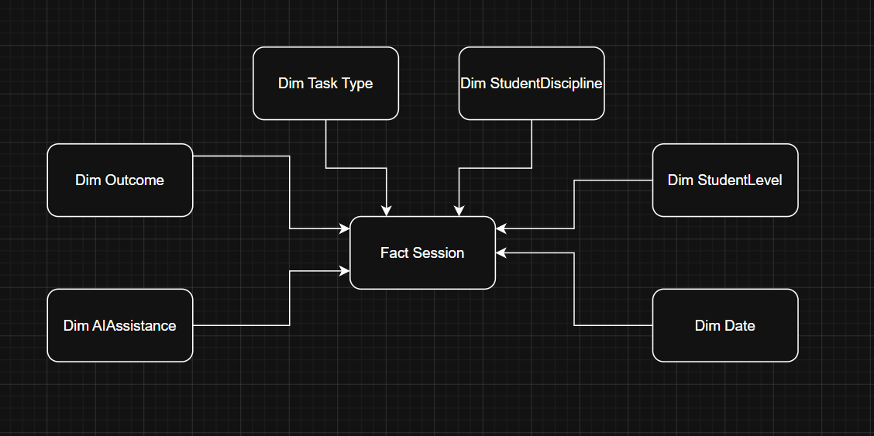

2.2 Logical Model
A logical model is a detailed, technology-independent representation of the data or information requirements of a system or business domain. It describes what data is needed and how it is structured, without specifying how it will be physically implemented.

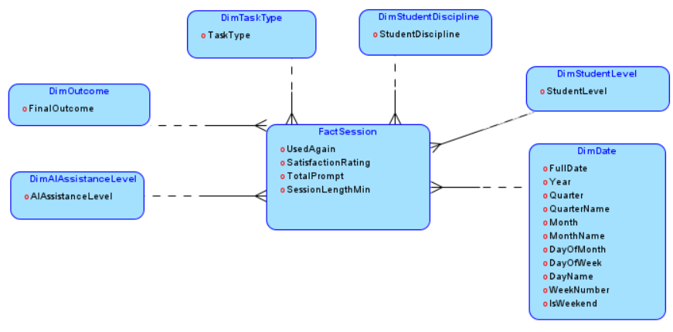

2.3 Relation Model
Tables Stored Physically:
- FactSession (Fact table storing measurable metrics: satisfaction, session length, prompts, reuse)
- DimDate (Calendar date attributes with pre-populated 2020–2030 range)
- DimStudentLevel (Student academic level classifications)
- DimDiscipline (Academic discipline categories)
- DimOutcome (Final session outcome statuses)
- DimTaskType (Task type classifications)
- DimAIAssistanceLevel (AI assistance intensity levels)

Structure:
- Surrogate keys (NUMERIC(28) with IDENTITY) used for all dimension and fact tables
- Foreign key relationships defined between FactSession and all six dimensions
- Star schema with one central fact surrounded by lookup dimensions, optimized for analytical querying
- Error schema with dedicated lookup failure tables for ETL error handling
- Clustered primary keys on all tables; DimDate pre-seeded via system object cross join

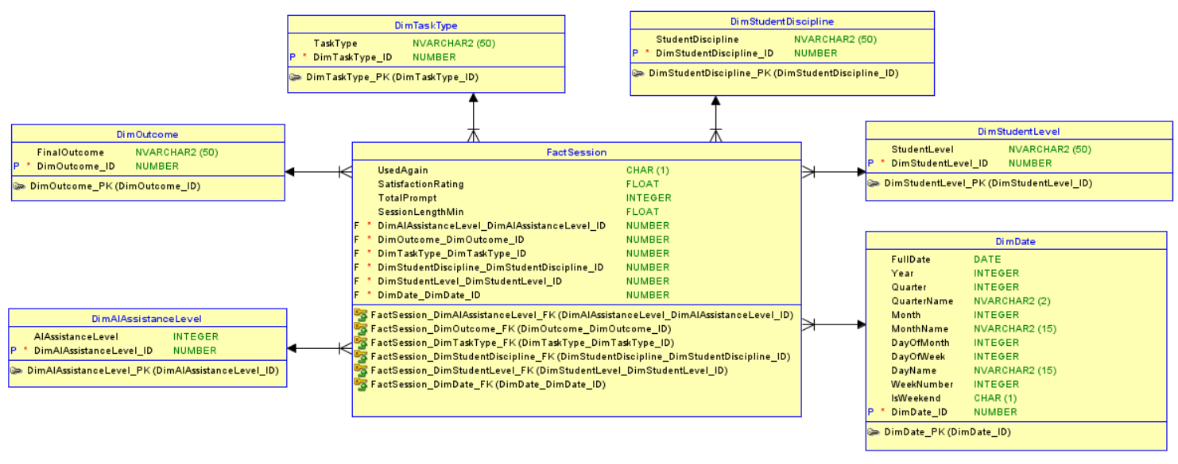

3. SSIS Overview
To build a clean, high-quality data model for analysis, a robust ETL (Extract, Transform, Load) pipeline was implemented using SQL Server Integration Services (SSIS). The pipeline processes raw flat files, performs necessary transformations and data cleansing, and loads the refined data into a structured Data Warehouse (DWH).

The ETL process is divided into three main layers:
• ODS (Operational Data Store)
• Staging Area
• Data Warehouse (DWH)

- Operational Data Store (ODS)
In the ODS layer, data from the 1 source CSV files was loaded using Flat File Source components. This raw table preserve the original format and act as a landing zone for further transformations.
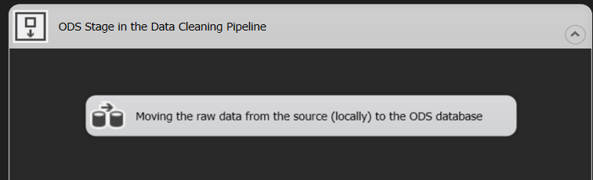

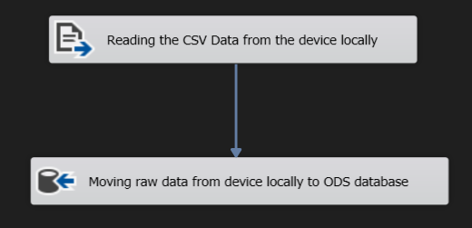

- Staging Area (STG)
In the Staging layer, data was transformed and cleaned to prepare it for loading into the final warehouse schema. We are still using the One Big Table Design Pattern:
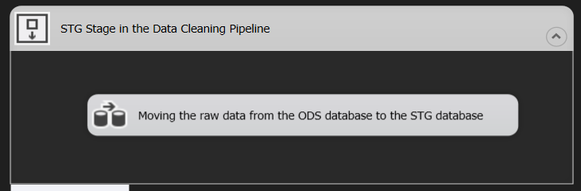

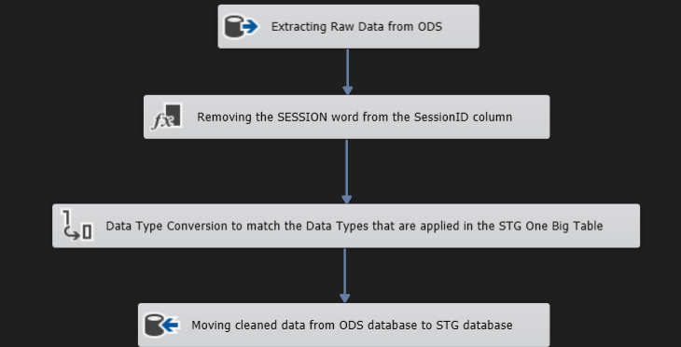

- Data Warehouse (DWH)
The final step in the ETL process was loading the clean data into the Data Warehouse layer, which follows a star schema structure.
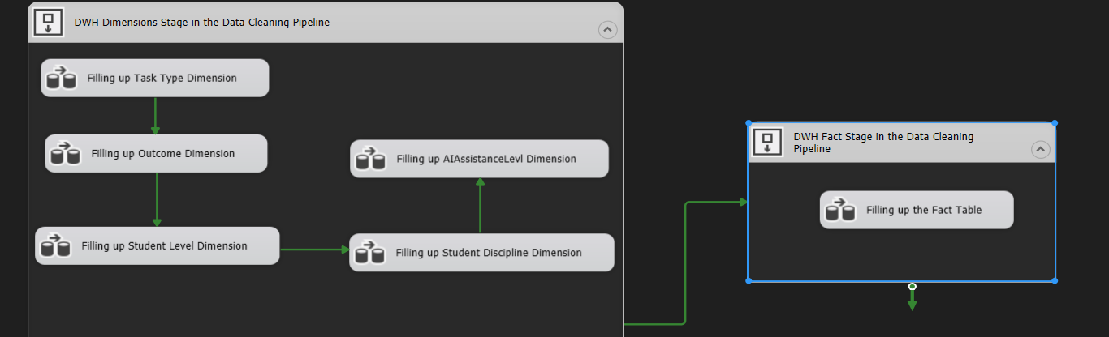

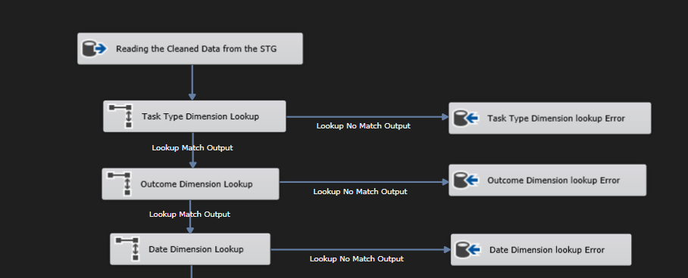
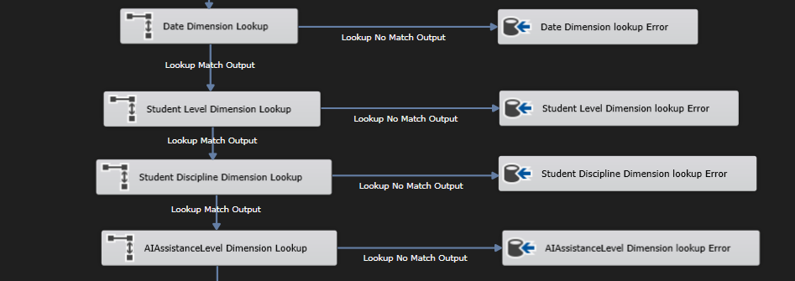
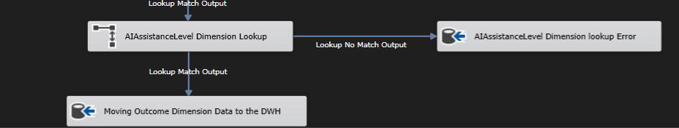

4. Power BI Overview
Page 1: Landing Page
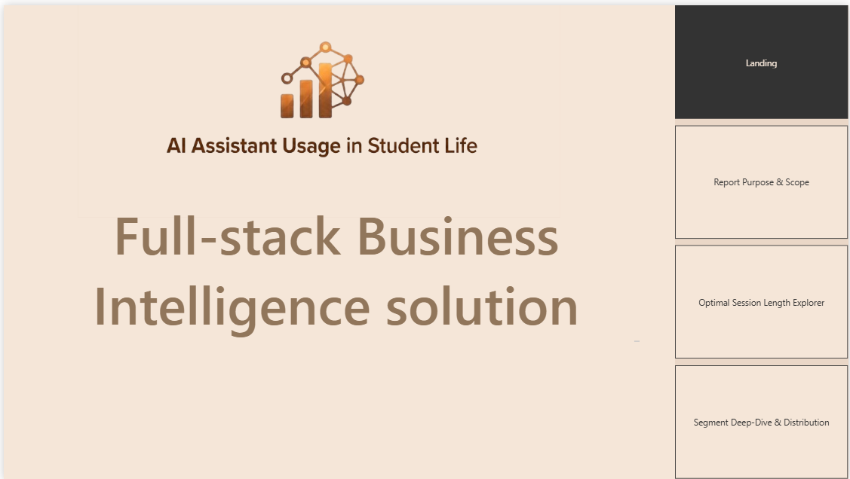

Page 2: Report Purpose & Scope

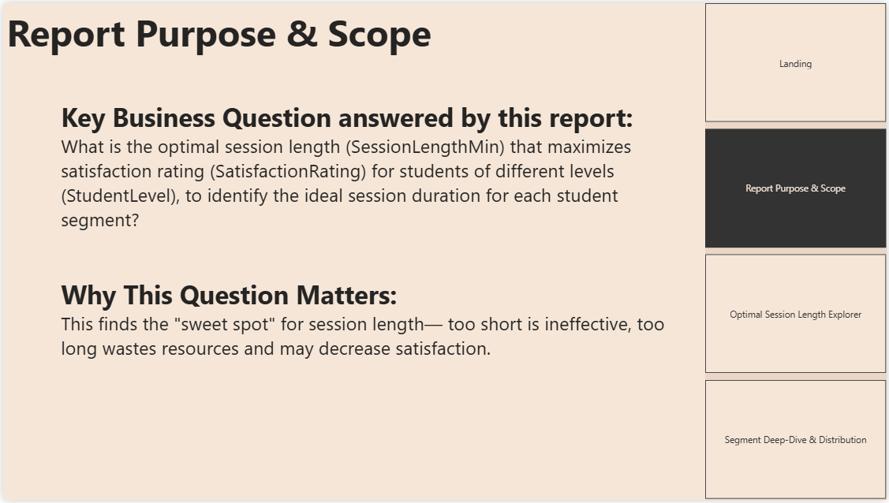

Page 3: Optimal Session Length Explorer

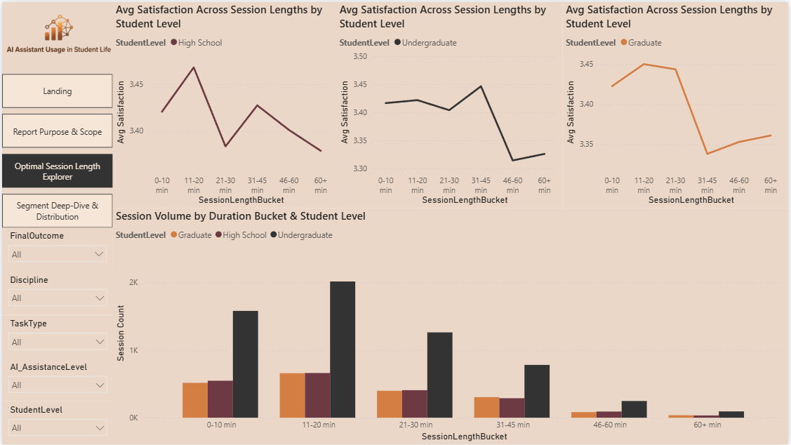

Page 4: Segment Deep-Dive & Distribution

